Comedy, Tragedy, Satire
The ancient Greeks loved live theatre. Every town had at least one open air theatre. These theatres attracted crowds of 15,000 people. per performance. At first, Greek theaters were not used for plays. They were used for music, songs, and dances in honor of the Greek gods. Songs were sung by a chorus. These songs told stories of the gods, the stories the Greek knew and loved. As time went on, some of the chorus began acting out the stories. Greek writers began to write plays for the chorus to sing and act out.
There was almost no scenery or backdrops. There were two simple machines used on the stage. One was to lift an actor into the air, who was playing the part of a god. The other machine made a thunder sound, as Zeus was often a character in the play, and the sound of thunder was something Zeus did according to the ancient Greeks. The actors wore masks.
Each town bragged about how wonderful their plays were and how marvelous their actors were. The Greeks were very competitive. They had drama contests between towns. Winners were treated with great respect, nearly as much respect as the Olympic winners.
Many Greeks tried to become famous playwrights. One of the most successful and famous was a Greek named Sophocles. Sophocles wrote 120 plays! His plays were a popular draw.
The Greek architects built theatres on hillsides. That let them position long benches in rows, one above the other, so that everyone could see what was happening on the stage. The stage was located at the bottom of the hill. They could also hear. Greek theatres had great acoustics by design.
The ancient Greeks invented three types of plays. Tragedies always had a sad ending. Comedies always had a happy ending. And satires poked fun at real people and events. (In ancient Greece, it was illegal to poke fun at the gods. Punishment for mocking the gods was death.) Comedies and tragedies entertained, but a well written satire could sway public opinion.
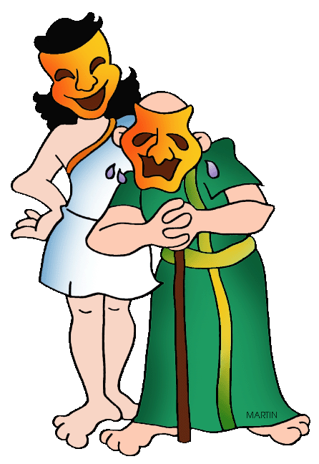
Each play was told in two different ways at the same time. The story was told out loud by a Greek chorus. The story was acted out by performers who did not speak. These performers, or actors, told story using masks and gestures. The same actor might play several different roles. All he had to do was switch masks. Still, it took talent to be a great actor, just as it does today. Thespis was one of the most famous and successful actors in all of ancient Greece. In his honor, actors today are called thespians.
- Identify at least 2 plays by Sophocles and explain his impact on modern theatre.

- Explain how Greek theatres were built and the impact they had on modern theatres.

- What is a tragedy in Greek theatre? Identify at least 2 Greek tragedies.

- What is a comedy in Greek theatre? Identify at least 2 Greek comedies.

- What is a satire in Greek theatre? Identify at least 2 Greek satires.

- Which of the three genres were most popular in Greek theatres?

- Which of the three genres would you enjoy the most? Why?

You may recruit actors as needed for the following activity.

- Write a tragedy, comedy, or satire that will be acted out in class. Content may vary, but must be appropriate to act out in class. Performance must last between 5-10 minutes. Playwright must be submitted and approved before a performance date will be set.

ΒΡΕΑΚ Α ΛΕΓ!
(BREAK A LEG!)

